SAMPLE PAPER FINAL SEMESTER
NUMERICAL ANALYSIS
BESE-14(A&B)

Instructor: Gp Capt Umar Farooq (Retd) Max Time: 2 H & 30 M
Max Marks: 30

ATTEMPT ALL QUESTIONS . SHOW THE DETAILS OF YOUR WORK

Q1.What do you mean by the term ‘Fixed point of a function ‘. Show rigorously that 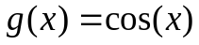 has a unique fixed point in [0, 1]. Use this fact to find out the solution of 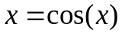 using five iterations. (7)

Q2. The number  of repeated bisection method to guarantee that the 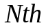midpoint is an approximate to a zero and has an error less than the pre-assigned value 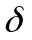 is:
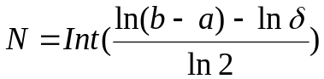
Derive the above relation.
How much iteration would you require to evaluate the root of 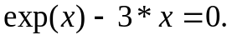
Correct to 10-signicaficant figures. (4+3)

Q3. Use the Newton Raphson method to calculate first five approximate value of root of 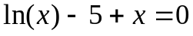 in the interval [3.2,4.0]. (7)

Q4. Consider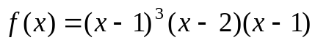. If 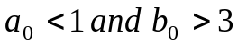are selected. Show that bisection method will converge to one of the three zeros of f(x) in the interval 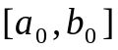.However, when 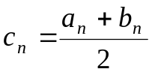 is not equal to 1, 2 or 3 for any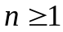, then bisection method will never converge to which zero(s)? Why?
(4+4)

Q5. (a) Consider 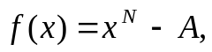where is a positive integer. Derive the recursive formula for finding root of 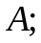
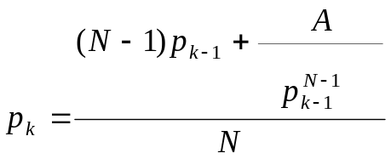 (4)
(b) What real values is the solution to 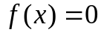 for the various choices of
and  that can arise? (3)

Q6. (a) When the population 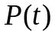 of certain area is bounded by the limiting value 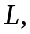it follows a logistic curve and has the form 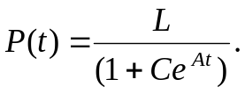Find 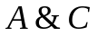 for the following data:-
(0,200),(1,400),(2,650),(3,850),(4,950), and 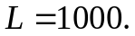 (4)

(b) Express 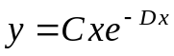 in linearized form. (3)

Q7.(a) The solid of revolution obtained by rotating the region under the curve 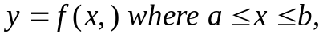about the x-axis has surface area given by:
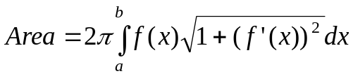
Approximate the surface area using the composite Simpson rule with M=5 for the curve: 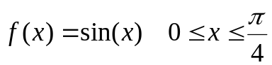 . (4) (b) Find the number and the step size so that the error for the composite
(3)

